**NAME: - AYUSH KACHHADIYA**

**SAP I’D: - 500095872**

INLINE HTML CODE: -

<html>

<head>

</head>

<body>

<h1 style="color:blue;">I N L I N E</h1>

<p style="color:red;">I N L I N E</p>

</body>

</html>

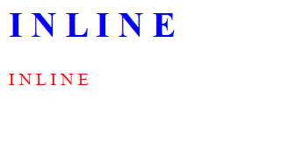

INTERNAL HTML CODE: -

<html>

<head>

<style>

body {background-color: powderblue;}

h1 {color: blue;}

p {color: red;}

</style>

</head>

<body>

<h1>I N T E R N A L</h1>

<p>I N T E R N A L</p>

</body>

</html>



EXTERNAL HTML CODE: -

<html>

<head>

<link rel="stylesheet" href="style.css">

</head>

<body>

<h1>E X T E R N A L</h1>

<p>E X T E R N A L</p>

</body>

</html>

